COMPUTER



I C T

Submitted By:

Ma. Jillian Marietoni O. Angeles

7-STE B – Reid

Submitted to:

Ms. Julie Agustin

COMPUTER

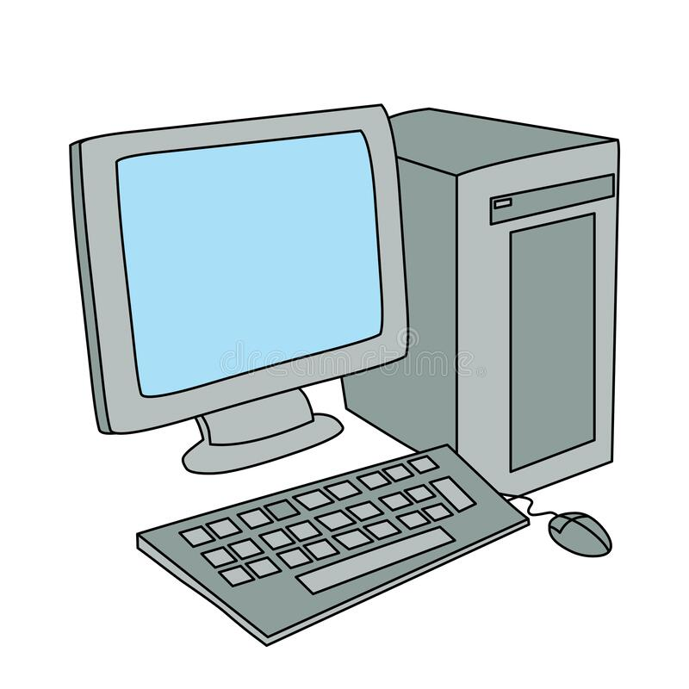

* A computer is defined as an electronic machine that uses input from the user, process or stores it, and generates the desired output data. It can be as simple as a calculator or as complicated as a system of thousands of computers to complete highly complex tasks.

Advantages and disadvantages of computer

Advantages

* A computer does things faster than humans
* Availability of information
* Computers help you save time
* Students can attain a variety of knowledge
* Entertainment use

Disadvantages

* Excessive use of computers leads to distraction
* More screen time may affect your eyesight
* Computer users may become less socially active
* Health complaints are common disadvantages of computer
* Computer is expensive